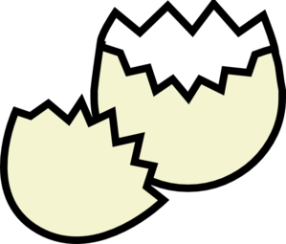
Rotor Egg Drop Design Notebook
The first step in the process of building your Rotor Egg Drop Apparatus will be to do research and come up with a design plan.
Research:
Explain the following scientific terms and how they will relate to this event
Gravity:

Mass:

Potential Energy:

Kinetic Energy:

Aerodynamics

Rotor

Lift:

Bernoulli’s Principle:

Design Tips:
What are three design tips that you read in your research that you plan to use?

Predictions: How will the following affect the rate of descent of your rotor egg drop?
Mass:

Rotor Size:

Rotor Shape:

Rotor Angle:

Planning:
Please sketch your initial design for your rotor egg drop apparatus and label the parts. Also, tell how large each of the parts will be in cm. Feel free to draw multiple possible designs.

Design Reasoning:
Use scientific reasoning to describe why you chose the design and materials that were sketched on the previous page. Must explain at least three different parts of the rotor egg drop apparatus.

Test Runs:
Now it is time for you to test your device. Please use this space and the next page to record your data from trial runs in an organized manner (data tables). Also, be sure you keep track of observations you make during these trials.

Test Runs Continued:

Design Change Log:
After completing several different test runs, diagram and explain the design changes you make to your rotor egg drop apparatus. Also include reasoning for the changes. You must record a minimum of three design changes.

